Q1: One-way ANOVA (Product Type vs. Manufacturing Costs)
Research Question: Does the Product Type significantly affect the Manufacturing Costs?
Hypotheses:
- $H_{0}$: $μ_{\text{cosmetics}}=μ_{\text{haircare}}=μ_{\text{skincare}}$
  - (Null: The mean manufacturing costs are equal for all three product types.)
- $H_{a}$: At least two of the population means are different.
  - (Alternative: The mean manufacturing cost differs for at least one product type compared to the others.)
Test Used: One-way Analysis of Variance (ANOVA)
Significance Level: $α=0.05$
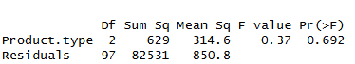
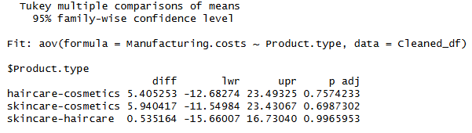
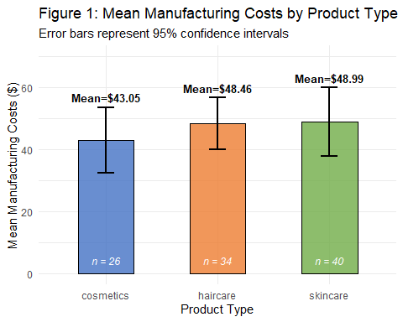
Figure 1: Mean Manufacturing Costs by Product Type with 95% Confidence Intervals
Results:
- F-statistic: 0.37
- p-value: 0.692
Conclusion:
- Decision: Since the p-value (0.692) > 0.05, we fail to reject the null hypothesis.
- Interpretation: There is insufficient evidence to conclude that product type (cosmetics, haircare, or skincare) has a significant effect on manufacturing costs. The Tukey HSD post-hoc test confirms that no pairwise comparisons between the three product types are statistically significant (all adjusted p-values > 0.69).

Q2: Two-way ANOVA (Shipping Carrier & Location vs. Shipping Costs)
Research Question: How do Shipping Carrier and Location interact to affect Shipping Costs?
Hypotheses:
Main Effect of Shipping Carrier:
- $H_{0}$: $μ_{\text{Carrier A}}=μ_{\text{Carrier B}}=μ_{\text{Carrier C}}$
- $H_{a}$: At least two carriers have different mean shipping costs.
Main Effect of Location:
- $H_{0}$: $μ_{\text{Bangalore}}=μ_{\text{Chennai}}=μ_{\text{Delhi}}=μ_{\text{Kolkata}}=μ_{\text{Mumbai}}$
- $H_{a}$: At least two locations have different mean shipping costs.
Interaction Effect (Carrier × Location):
- $H_{0}$: There is no interaction between Shipping Carrier and Location.
- $H_{a}$: There is an interaction between Shipping Carrier and Location.
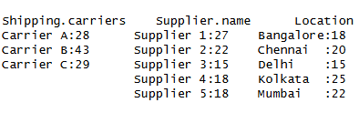
Test Used: Unbalanced design Two-way Factorial ANOVA
Significance Level: $α=0.05$
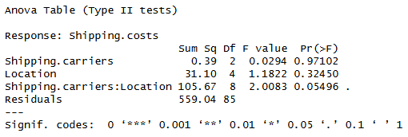
Conclusion:
Main Effect (Carrier): Fail to reject $H_{0}$. There is no significant main effect of shipping carrier on shipping costs (p = 0.97).
Main Effect (Location): Fail to reject $H_{0}$. There is no significant main effect of location on shipping costs (p = 0.32).
Interaction Effect: Fail to reject $H_{0}$ at the strict 0.05 level. However, the p-value (0.055) is marginally significant, suggesting a potential trend. Based on the conventional $α=0.05$ threshold, we conclude there is insufficient evidence of a statistically significant interaction between shipping carrier and location.

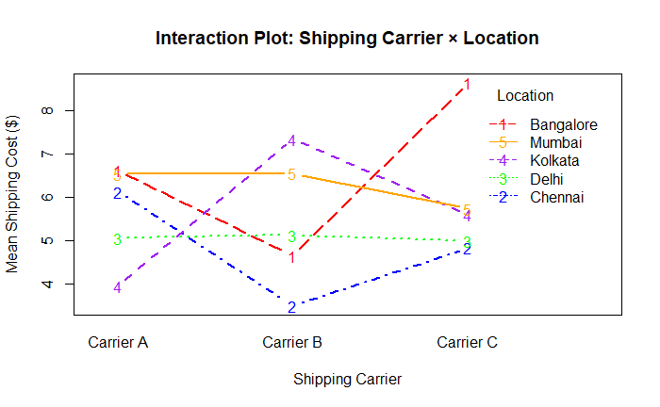
Figure 2: Interaction Plot – Shipping Carrier × Location
Figure 2 shows the interaction plot based on raw mean shipping costs. However, because the design is unbalanced (see Table below for cell counts), the statistical tests used Type II sums of squares to account for unequal group sizes.
